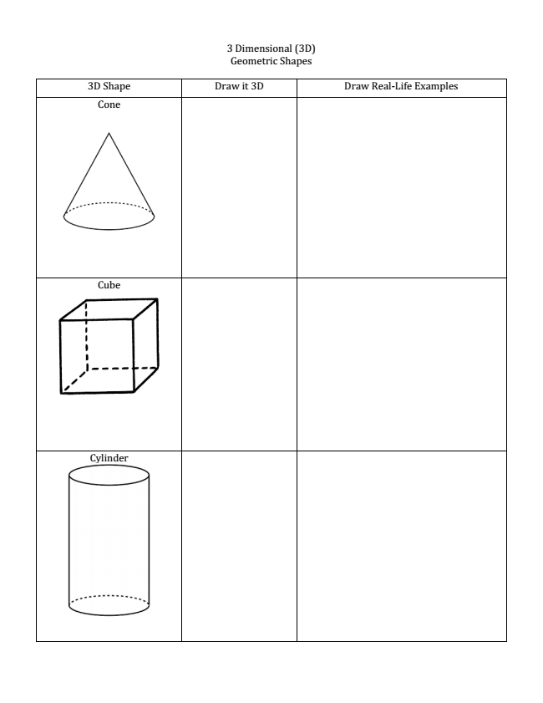
3 Dimensional (3D) Geometric Shapes 3D Shape Draw it 3D Draw Real-­‐Life Examples
Cone

Cube

Cylinder

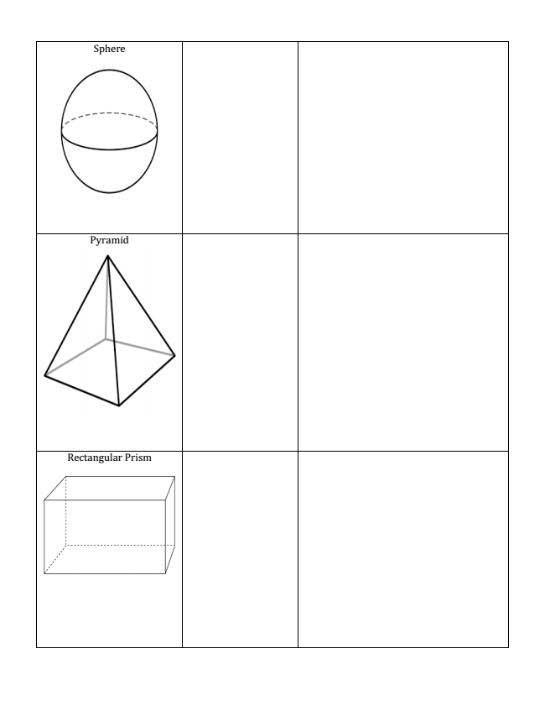

Pyramid

Rectangular Prism

Sphere

